Dijkstra’s Algorithm

David Graves
Colorado State University Global
CSC506
Dr. Brian Holbert
April 28, 2025

Dijkstra’s Algorithm and Route Planning
Finding directions for traveling to different places in my car today looks very different than it did in the past. I remember a time not that long ago when I would attempt to plan a trip with multiple stops taking into consideration tacit knowledge of traffic patterns and inserting educated guesses on what stops made the most sense to visit in a particular order. I feel like I was able to compute a pretty good path by myself, but today we have many tools at our fingertips that can take real time traffic, weather and other data into account to definitively provide the “best” or fastest trip including one or many stops. One way our phones and other computers do this is through using resources like Dijkstra’s algorithm which, “tries to find the shortest path in a graph, where the weights of the edges are already known”. (Madridano et al, 2021) It does this by computing the shortest distance to all stops, then using a priority queue iterates and ultimately finds the shortest path in time. One of the benefits of using this approach is that by incorporating real-time data into the algorithm it can dynamically change and update routing for a driver. One consideration that might change the performance is how often the algorithm updates or is run while in transit. For example, if I’m taking a trip across town and I leave at the start of rush hour and while in transit a crash occurs along my charted route I may not be updated fast enough to re-route if the application is not constantly or frequently updated. Realistically, for me this becomes a problem when I’m in the mountains where cell coverage is spotty and can’t receive updates, however even if I were forewarned of a problem with my route, unfortunately I’d be stuck since there typically aren’t many options for alternative routes in the mountains of Colorado. Another consideration is with actual application performance in how quickly answers are returned pending complexity of input. Generally, the program runs as O(E log V) where E represents the number of edges and time between the vertices as V. There are many instances where this comes in handy today, and none more than with the ubiquity of food delivery applications that exist. Dijkstra’s algorithm helps provide the most efficient trips for these delivery folks and can handle the different levels of complexity thrown at it with many changing variables. I’ve provided an example of Dijkstra’s algorithm below in Image 1 that shows how it might run for one of those applications.
Image 1 (Dijsktra’s Algorithm)
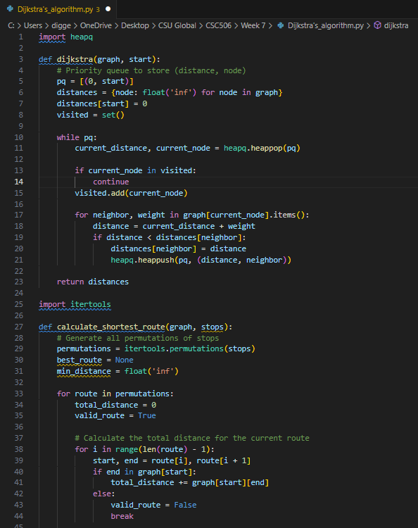
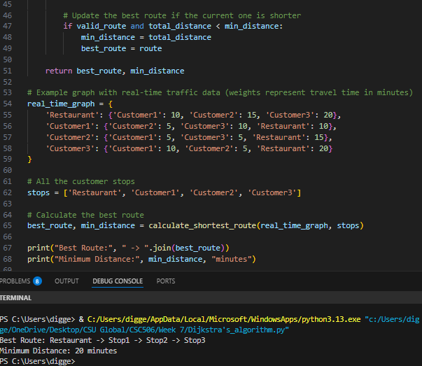
Reflection
Until now I didn’t know exactly how these routes were planned and updated, so this week’s exercise was fascinating to explore the inner working of this algorithm. I don’t think Edsger Dijkstra envisioned how powerful the work that “he conceived in twenty minutes while having a cup of coffee on a café terrace with his fiancée Ria” (CWI, 2025) back in 1956 would be today. Today his work, and others in this area underpin the backbone of many logistical solutions for supply chains, routing, and efficient planning helping companies and individuals find the shortest path to where they are going. This week’s exercise really tied together the real world to the work we are studying in a way that made a lot of sense to me and opened my eyes to how a few dozen lines of code can have such a direct impact on something that we all take for granted every day.
References
CWI.NL (2025) CWI.nl. Edsger W. Dijkstra: Brilliant, colourful, and opinionated.
https://www.cwi.nl/en/about/history/e-w-dijkstra-brilliant-colourful-and-opinionated/#:~:text=According%20to%20Dijkstra%2C%20'it%20was,'
Madridano, Angel & Al-Kaff, Abdulla & Martin, David & De La Escalera, Arturo
(2021, February 19). Expert Systems with Applications. Volume 173. Trajectory planning multi-robot systems: Methods and applications.
https://www.sciencedirect.com/science/article/abs/pii/S0957417421001019

